***Section* 1.9 – Hyperbolic Functions**

**Relationship Between Trigonometric and Hyperbolic Functions**

The trigonometric functions are based on relationships involving a circle, also known as ***circular*** functions. Specifically,  and  are equal to *x-* and *y-*coordinates, respectively, of the point  on the unit circle that corresponds to an angle of *t* radians.

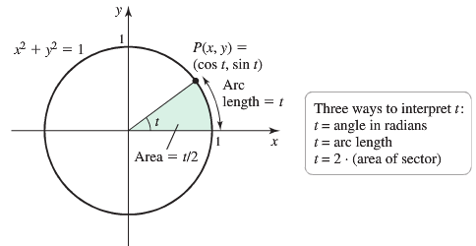

Observe that *t* is twice the area of the circular sector.

The ***hyperbolic*** ***cosine*** and ***hyperbolic*** ***sine*** are defined in analogous fashion using the hyperbola  instead the circle .

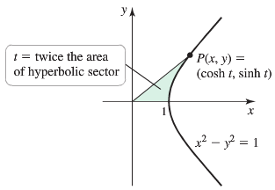

Consider the region bouunded by the x-axis, the right branch of the unit hyperbola , and a line segment from the origin to a point  on the hyperbola; let *t* equal twice the area of this region.

The hyperbolic functions are formed by taking combinations of the two exponential functions  and 

**Definitions, Identities, and Graphs of the Hyperbolic Functions**

The hyperbolic sine and hyperbolic cosine functions are defined by the equations



We pronounce: sinh *x* as “cinch *x*”, rhyming with “pinch *x*”

cosh *x* as “kosh *x*”, rhyming with “gosh *x*”

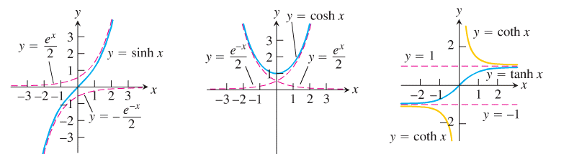

***Hyperbolic sine Hyperbolic cosine Hyperbolic tangent***

  

***Hyperbolic cotangent***



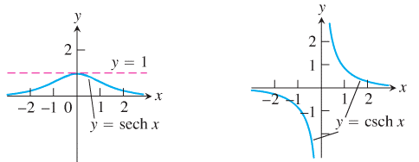

***Hyperbolic secant Hyperbolic cosecant***

 

***Example***

Derive identity 

***Solution***





 ***√***

***Example***

Use the fundamental identity  to prove that 

***Solution***



 ***√***

***Circular Functions:*** 

|  |  |  |
| --- | --- | --- |
| ***Identities*** | ***Derivatives*** | ***Integral*** |
|  |  |  |
|  |  |  |
|  |  |  |
|  |  |  |
|  |  |  |
|  |  |  |
|  |  |  |

***Example***

1. 



1. 





1.  





1. 











1. 













1. 



***Inverse Hyperbolic Functions***

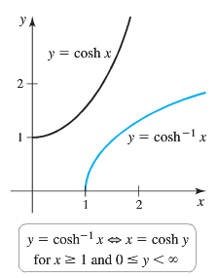 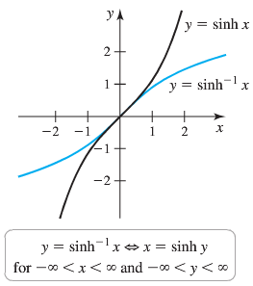

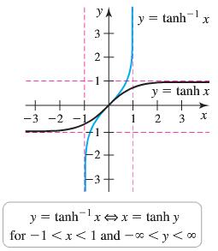 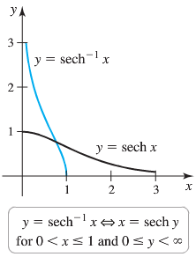

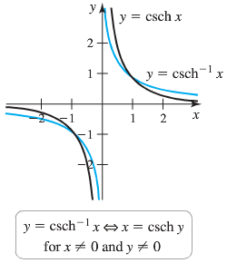 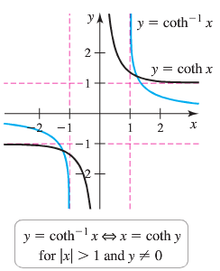



|  |  |  |
| --- | --- | --- |
| ***Identities*** | ***Derivatives*** | ***Integral*** |
|  |  |  |
|  |  |  |
|  |  |  |
|  |  |  |
|  |  |  |
|  |  |  |
|  |  |  |
|  |  |  |
|  |  |  |

***Example***

Show that if *u* is a differentiable function of *x* whose values are greater than 1, then



***Solution***



 

 





***Example***

Evaluate 

***Solution***















***Example***

Find the points at which the curves  and  intersect.

***Solution***











The points of intersection lie on the line , are 

***Example***

Find the derivative 

***Solution***



***Example***

Find the derivative 

***Solution***



***Example***

Evaluate 

***Solution***







***Example***

Evaluate 

***Solution***

 





**Applications of Hyperbolic Functions**

**The Catenary**: When a free-hanging rope or flexible cable supporting only its own weight is attached to 2 points of equal height, it takes the shape of a curve known as a ***catenary***.

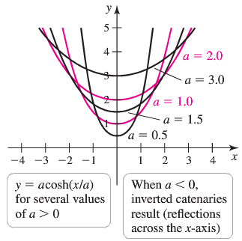

***Example***

A climber anchors a rope at 2 points of equal height, separated by a distance of 100 *feet*. in order to perform a Tyrolean traverse. The rope follows the catenary  over the interval . Find the length of the rope between the two anchor points.

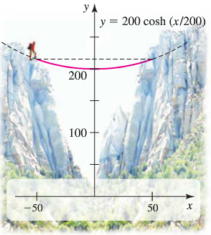***Solution***



 



 







***Example***

The velocity *v* (in *m/s*) of an idealized surface wave traveling on the ocean is modeled by the equation



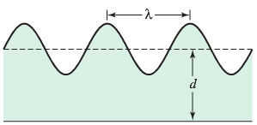

Where  is the acceleration due thegravity, *λ* is the wavelength measured in meters from crest to crest, and *d* is the depth of the undisturbed water, also measured in *meters*.

1. A sea kayaker observes several waves that pass neneath her hayak, and she estimates that  and . How deep is the water in which she is kayaking?
2. The deep-water equation for wave velocity is , which is an approximation to the velocity formula given above. Waves are said to be in deep water if the depth-to-wavelength ration  is greater than . Explain why  is a good approximation when .

***Solution***

1. ***Given***: , 











Therefore, the kayaker is in water that is about 2.4 *m* deep.

1. Since , then  is an incrasing function whose values approaches 1 as .

Also when , , which is nearly equal to 1.

These facts imply that whenever , we can replace  with 1 in the velocity formula, resulting in the deep-water velocity function .













Since  (***impossible***)















|  |  |
| --- | --- |
| ***Inverse Hyperbolic Functions*** | |
|  |  |
|  |  |
|  |  |
|  |  |
|  |  |
|  |  |

***Exercises Section* 1.9 – Hyperbolic Functions**

1. Rewrite the expression  in terms of exponentials and simplify the results as much as you can.
2. Rewrite the expression  in terms of exponentials and simplify the results as much as you can.
3. Prove the identities
4. 
5. 

Find the derivative of

|  |  |
| --- | --- |
|  |  |

|  |  |
| --- | --- |
|  |  |

Compute the following derivatives

|  |  |
| --- | --- |
|  |  |

1. Verify the integration 
2. Verify the integration 

Evaluate the integral

|  |  |
| --- | --- |
|  |  |

|  |  |
| --- | --- |
|  |  |

|  |  |
| --- | --- |
|  |  |

1. Derive the formula  for all real *x*. Explain in your derivation why the plus sign is used with the square root instead of the minus sign.
2. Find the linear approximation to  at  and then use it to approximate the value of .

Evaluate the limit:

|  |  |
| --- | --- |
|  |  |

1. Show that 
2. Show that 
3. Find the area of the region bounded by , and the unit circle
4. Find the area of the region bounded by the curves  and 

Find the area of the region bounded by the given:

|  |  |
| --- | --- |
|  |  |

Find the length of the curve

|  |  |
| --- | --- |
|  |  |

1. A region in the first quadrant is bounded above the curve *y* = cosh*x*, below by the curve *y* = sinh*x*, and on the left and right by the *y*-axis and the line *x* = 2, respectively. Find the volume of the solid generated by revolving the region about the *x*-axis.
2. Imagine a cable, like a telephone line or TV cable, strung from one support to another and hanging freely. The cable’s weight per unit length is a constant *w* and the horizontal tension at its lowest point is a vector of length *H*. If we choose a coordinate system for the plane of the cable in which the *x*-axis is horizontal, the force of gravity is straight down, the positive *y*-axis points straight up, and the lowest point of the cable lies at the point  on the *y*-axis, then it can be shown that the cable lies along the graph of the hyperbolic cosine



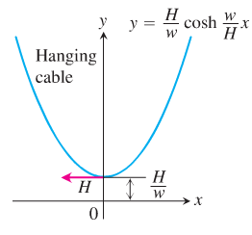

Such a curve is sometimes called a ***chain curve*** or a ***catenary***, the latter deriving from the Latin *catena*, meaning “*chain*”.

1. Let  denote an arbitrary point on the cable. The next accompanying displays the tension *H* at the lowest point *A*. Show that the cable’s slope at *P* is



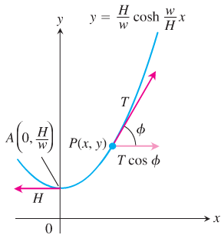

1. Using the result in part (*a*) and the fact that the horizontal tension at *P* must equal *H* (the cable is not moving), show that . Hence, the magnitude of the tension at  is exactly equal to the weight of *y* units of cable.
2. The length of arc *AP* is , where . Show that the coordinates of *P* may be expressed in terms of *s* as



1. The portion of the curve  that lies above the *x-*axis forms a catenary arch. Find the average height of the arch above the *x-*axis.
2. A power line is attached at the same height to two utility poles that are separated by a distance of 100 *feet*; the power line follows the curve . Use the following steps to find the value of *a* that produces a sag of 10 *feet*. midway between the poles. Use the coordinate system that places the poles at 
3. Show that *a* satisfies the equation 
4. Let , confirm that the equation in part (*a*) reduces to , and solve for ***t*** using a graphing utility. (2 decimal places)
5. Use the answer in part (*b*) to find a and then compute the length of the power line.
6. Imagine a climber clipping onto the rope and pulling hinself to the rope’s midpoint. Because the rope is supporting the weight of the climber, it no longer takes the shape of the catenary . Instead, the rope (nearly) forms two sides of an isosceles triangle. Compute the sag angle illustrated in the figure, assuming that the rope does not stretch when weighted. Assume the length of the rope is 101 *feet*.

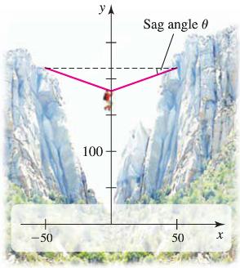

1. Find the volume interior to the inverted catenary kiln (an oven used to fire pottery).

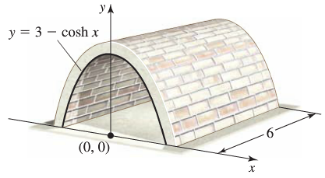

1. A person is holding a rope that is tied to a boat. As the person walks along the dock, the boat travels along a ***tractrix***, given by the equation

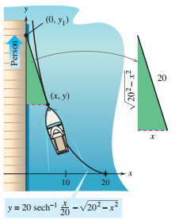



Where *a* is the length of the rope.

If , find the distance the person must walk to bring the boat 5 *feet* from the dock.